Tirumala Reddy Konireddy

Lab 03 report

Sensor Data Collection and HBase Uploading and Retrieval using webservice

**Data Collection from BLE sensor Tag and Android Mobile device**

I had imported our tutorial program App1 –App3 GPS into our local Eclipse, which is able to write data about Accelerometer service from BLE sensor tag, present Date and GPS location of Android Mobile device. I had understood the code and methods related to enabling, reading and notifying different sensors of BLE sensor tag. I had developed that code to write Humidity, Temperature, Gyroscope and Pressure values of room using sensor tag services.

Please find my source files in my github :

https://github.com/tkhgf/Big-data-labs/tree/master/lab%2003

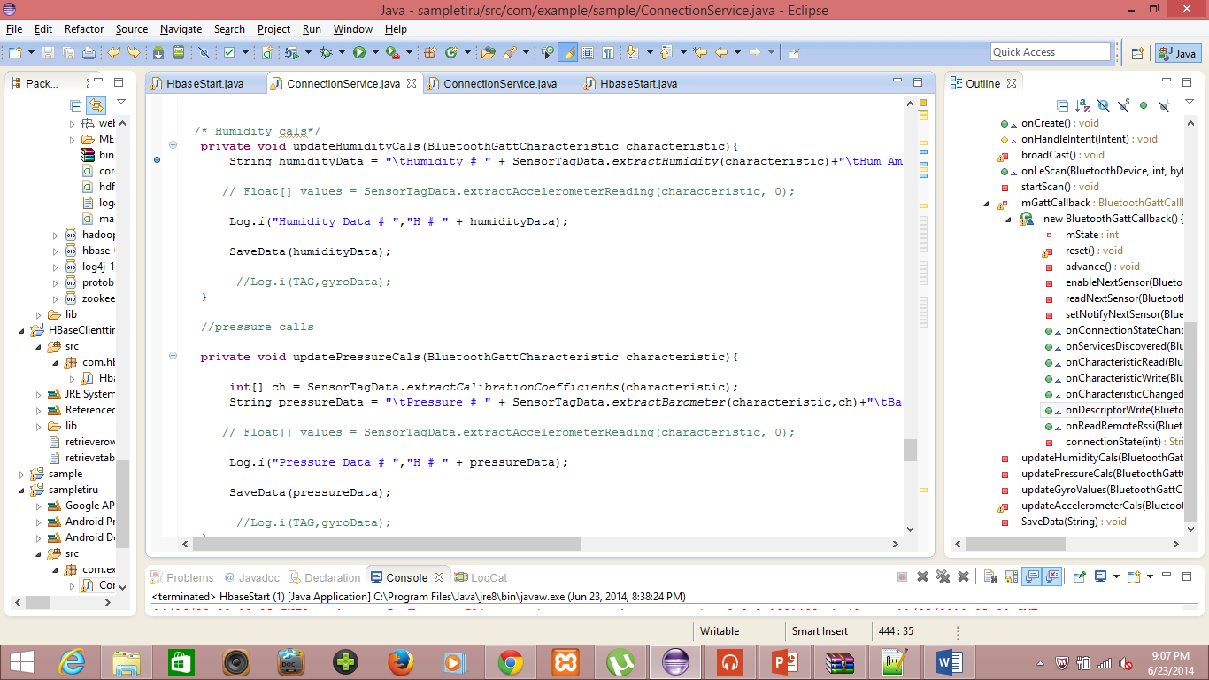

I had found the accelerometer, GPS , Humidity sensor enabling while running application in Android device as below.

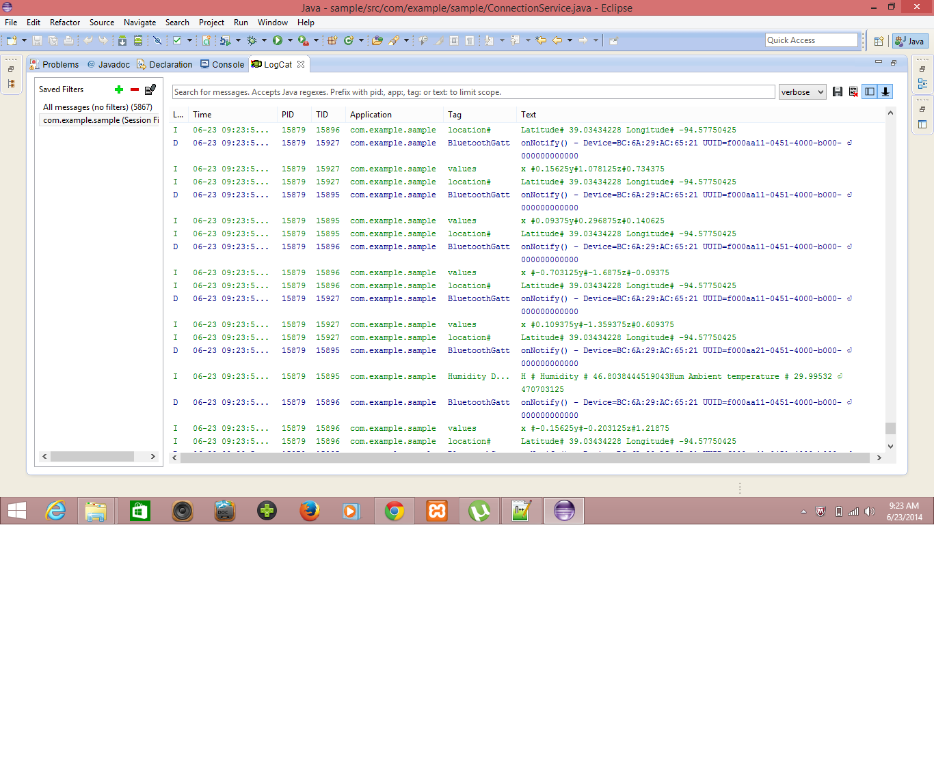

I had successfully written the Humidity and Temperature data along with the old data services as below.

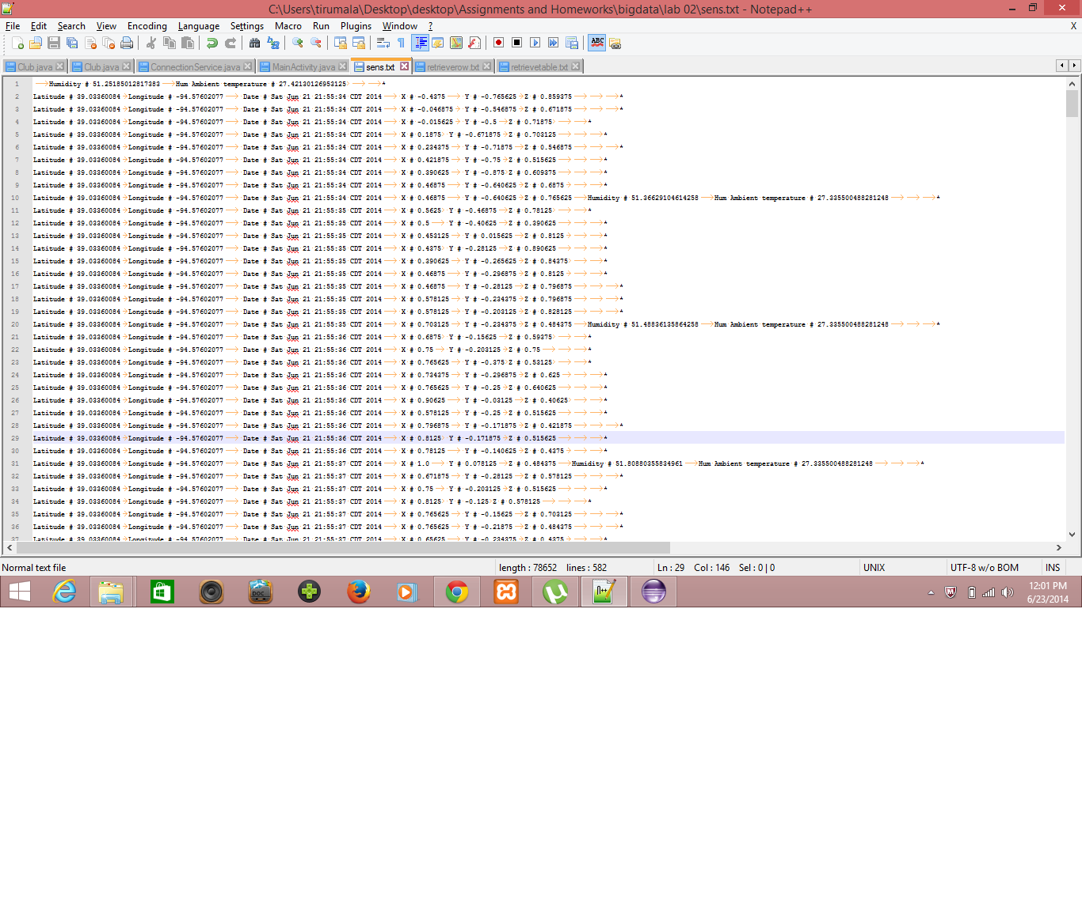

**Uploading Data to HBase using Web service**

I had developed a web service to upload all this data into HBASE server for using this data to train gestures as follows,

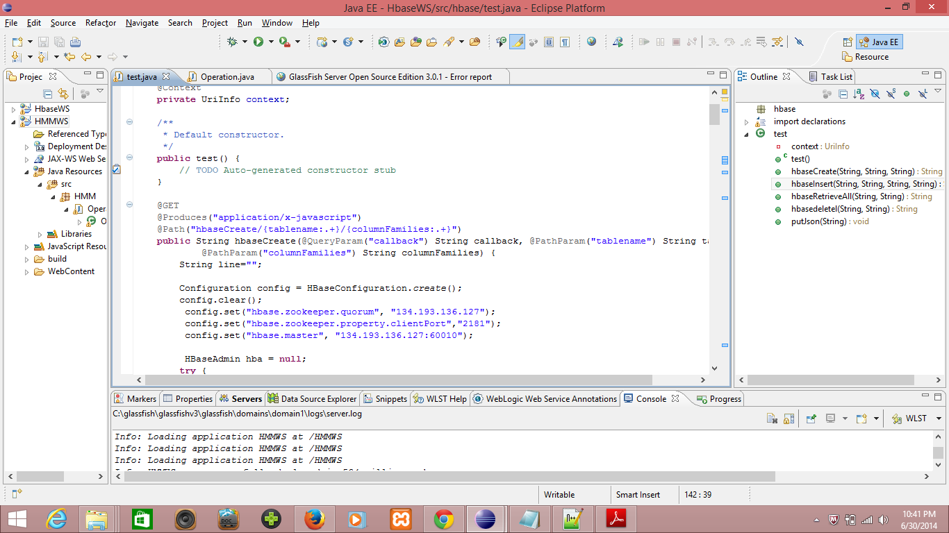

I had created a table in HBASE with my name TirumalaLab3Table,

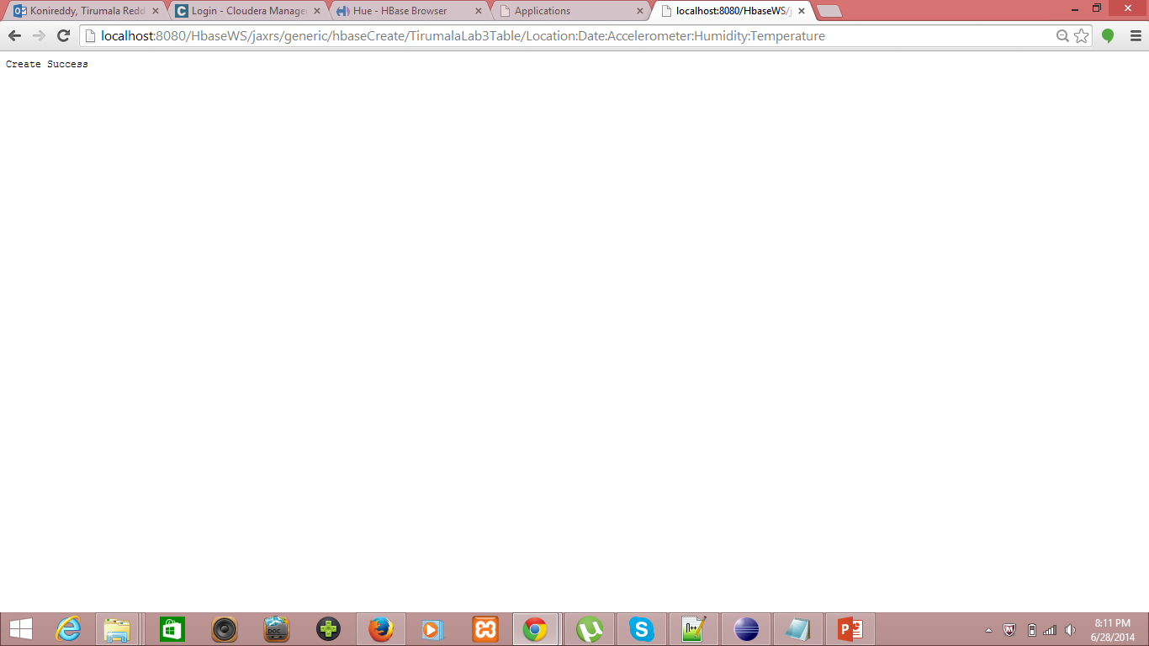

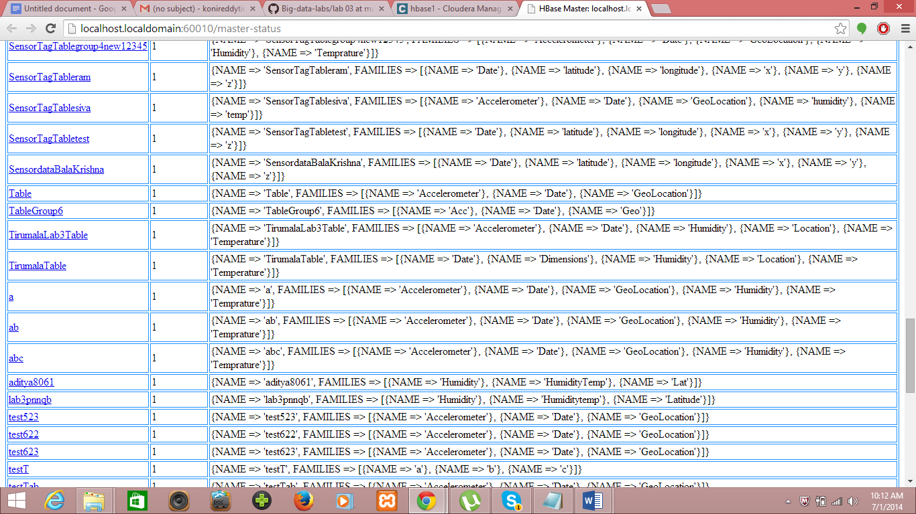

I had inserted the sensor data into the text file as follows, using webservice

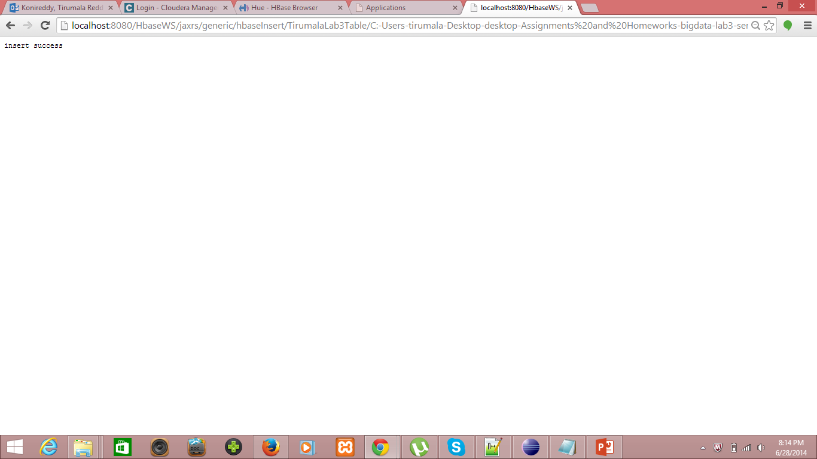

The data uploaded to Hbase can be viewed Hbase browser as follows,

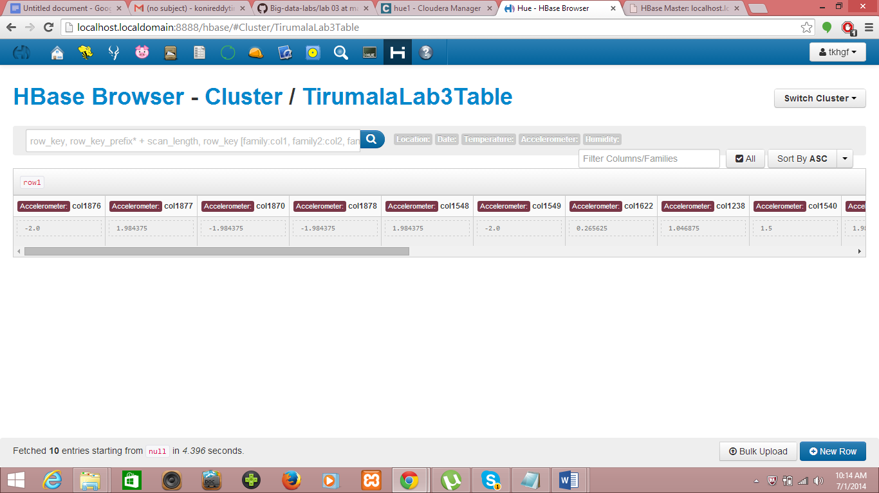

I had successfully accessed data stored in Hbase on retrieval,

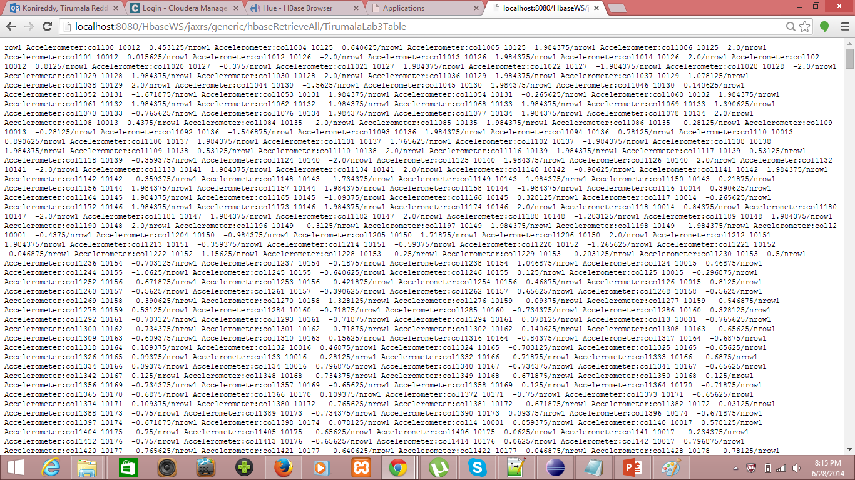

**Android Application**

I had developed the hbase create table, Upload sensor data and retrieval of data into hbase.

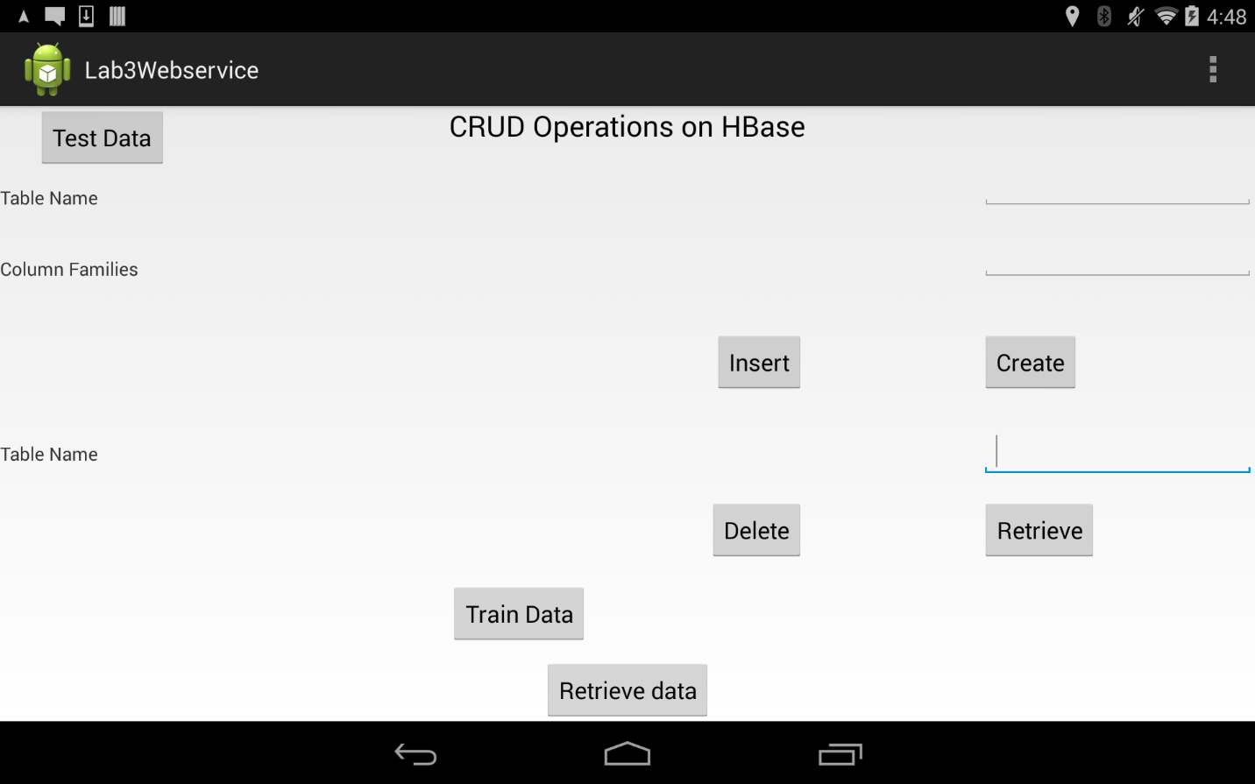

Here i have created the TirumalaLab3Table in the Emulator using 10.0.2.2 port to access local host glassfish webservice.

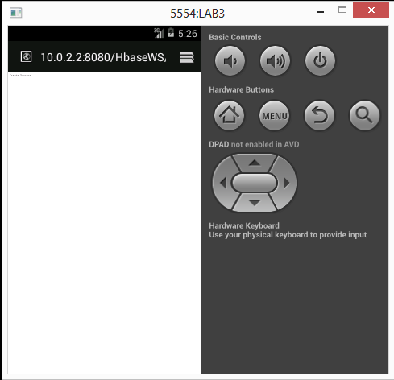

Here i have inserted the data into TirumalaLab3Table in the Emulator using 10.0.2.2 port to access local host glassfish webservice.

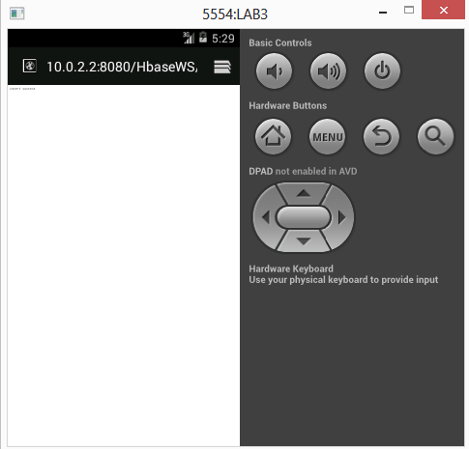

Here i have retrieved the data into TirumalaLab3Table in the Emulator using 10.0.2.2 port to access local host glassfish webservice.

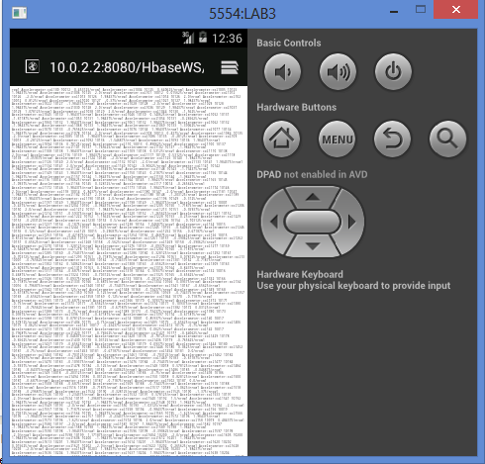

**Deletion of Table**

